Summer Reading-Incoming Grade 5
Note: Reading difficulty increases from top to bottom.
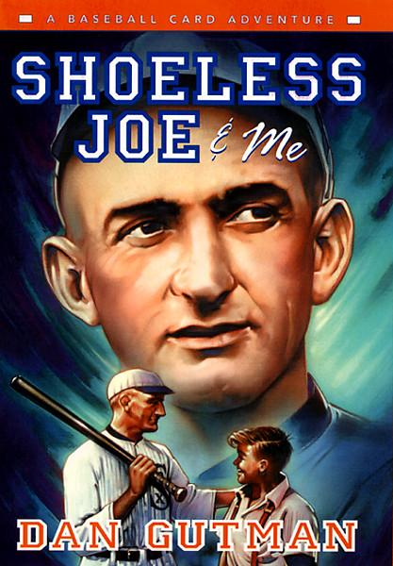 | Shoeless Joe & Me: A Baseball Card Adventure  Since Joe Stoshack first traveled back in time through a baseball card to meet Honus Wagner, he knew he had a special gift. So when sports card shop owner Flip tells Stosh all about his hero, Shoeless Joe Jackson -- about the scandal that destroyed the star player's career -- Stosh gets an idea. If he travels back in time with a 1919 baseball card in his hand, he just might be able to prevent the infamous Black Sox Scandal from ever taking place. And if he could do that, Shoeless Joe Jackson-one of the greatest players in the history of the game -- would finally take his place in the Baseball Hall of Fame, where he truly belongs.  But can Stosh prevent that tempting envelope full of gambling money from making its way to Shoeless Joe's hotel room before the big game?
No More Dead Dogs
Nobody understands Wallace Wallace. This reluctant school football hero has been suspended from the team for writing an unfavorable book report of Old Shep, My Pal. But Wallace won't tell a lie-he hated every minute of the book! Why does the dog in every classic novel have to croak at the end? After refusing to do a rewrite, his English teacher, who happens to be directing the school play Old Shep, My Pal, forces him go to the rehearsals as punishment. Although Wallace doesn't change his mind, he does end up changing the play into a rock-and-roll rendition, complete with Rollerblades and a mo-ped!
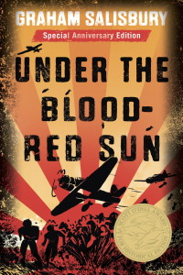 | Under the Blood Red Sun  Tomi was born in Hawaii. His grandfather and parents were born in Japan, and came to America to escape poverty.  World War II seems far away from Tomi and his friends, who are too busy playing ball on their eighth-grade team, the Rats.  But then Pearl Harbor is attacked by the Japanese, and the United States declares war on Japan. Japanese men are rounded up, and Tomi’s father and grandfather are arrested. It’s a terrifying time to be Japanese in America. But one thing doesn’t change: the loyalty of Tomi’s buddies, the Rats.
It Only Looks Easy
Before the first day of seventh grade is over, Kat Randall’s year is nearly ruined. When her beloved dog, Cheddar, is hit by a woman with Alzheimer’s disease, Kat reacts impulsively, leaving school on a “borrowed” bike to get to the vet. Then the bike gets stolen. Kat often does the wrong thing for the right reason, but now she has gone from being a person you can count on to someone you probably shouldn’t. Suddenly she is looked at differently by everyone at school—even the police are keeping an eye on her. If “one of the best years” of her life starts out like this, what’s next?

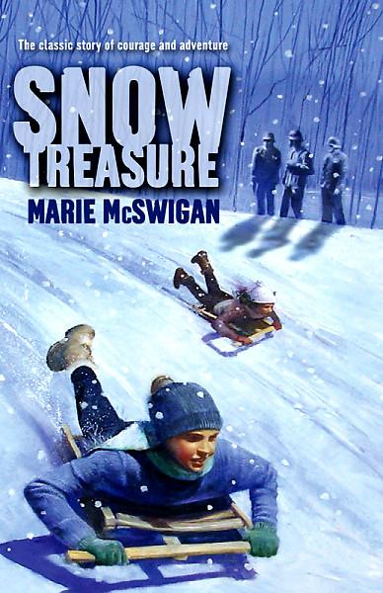 | Snow Treasure  In 1940, when the Nazi invasion of Norway reaches their village in the far north, twelve-year-old Peter and his friends use their sleds to transport nine million dollars’ worth of gold bullion past the German soldiers to the secret harbor where Peter's uncle keeps his ship ready to take the gold for safekeeping in the United States.
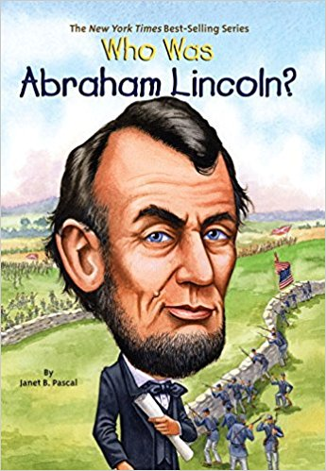 | Who Was Abraham Lincoln?  Born to a family of farmers, Lincoln stood out from an early age-literally! (He was six feet four inches tall.) As sixteenth President of the United States, he guided the nation through the Civil War and saw the abolition of slavery. But Lincoln was tragically shot one night at Ford’s Theater-the first President to be assassinated.
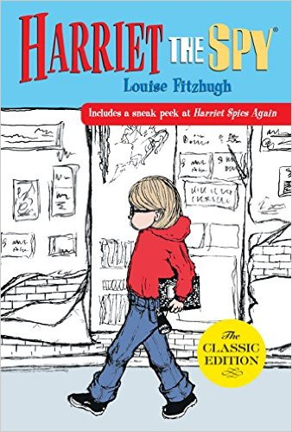 | Harriet the Spy  Harriet M. Welsch is a spy. In her notebook, she writes down everything she knows about everyone, even her classmates and her best friends. Then Harriet loses track of her notebook, and it ends up in the wrong hands. Before she can stop them, her friends have read the always truthful, sometimes awful things she’s written about each of them. Will Harriet find a way to put her life and her friendships back together?
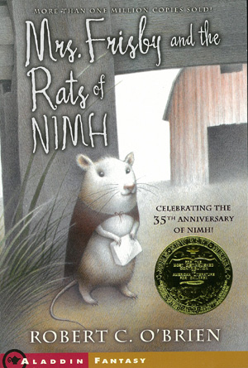 | Mrs. Frisby and the Rats of NIMH  Mrs. Frisby, a widowed mouse with four small children, is faced with a terrible problem. She must move her family to their summer quarters immediately, or face almost certain death. But her youngest son, Timothy, lies ill with pneumonia and must not be moved. Fortunately, she encounters the rats of NIMH, an extraordinary breed of highly intelligent creatures, who come up with a brilliant solution to her dilemma. And Mrs. Frisby in turn renders them a great service.
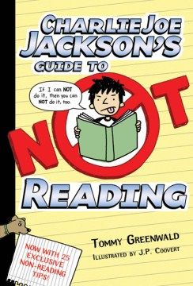 | Charlie Joe Jackson’s Guide to Not Reading  Charlie Joe Jackson may be the most reluctant reader ever born. And so far, he's managed to get through life without ever reading an entire book from cover to cover. But now that he's in middle school, avoiding reading isn't as easy as it used to be. And when his friend Timmy McGibney decides that he's tired of covering for him, Charlie Joe finds himself resorting to desperate measures to keep his perfect record intact.
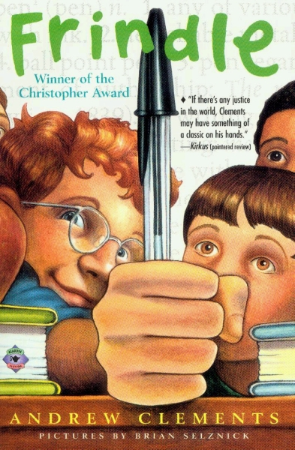 | Frindle  He really just likes to liven things up at school -- and he's always had plenty of great ideas. When Nick learns some interesting information about how words are created, suddenly he's got the inspiration for his best plan ever...the frindle. Who says a pen has to be called a pen? Why not call it a frindle? Things begin innocently enough as Nick gets his friends to use the new word. Then other people in town start saying frindle. Soon the school is in an uproar, and Nick has become a local hero. His teacher wants Nick to put an end to all this nonsense, but the funny thing is frindle doesn't belong to Nick anymore. The new word is spreading across the country, and there's nothing Nick can do to stop it.
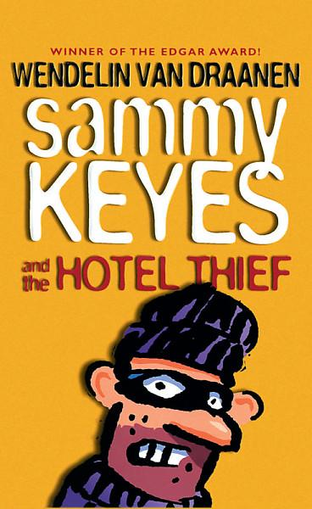 | Sammy Keyes and the Hotel Thief  This book opens with Sammy watching a crime in progress. And when the man with the wad of cash in one hand and the open purse in the other catches Sammy watching him, the chase is on--but is Sammy on the trail of the thief, or is he on hers? If the police don't believe Sammy's story about a thief with black gloves, black glasses, and a black beard, she isn't too surprised. Vice principal Caan didn't exactly believe her either when she explained that she couldn't possibly have broken Heather's nose. Well, Sammy's not putting up with this. Does she look like a liar? She knows what she saw and how hard she can hit. And somehow she's going to prove it.
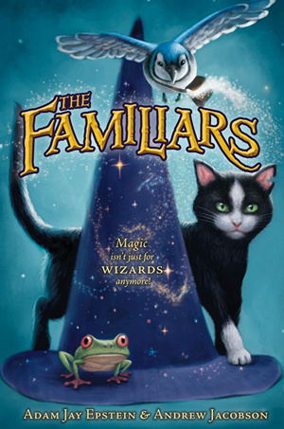 | The Familiars  When Aldwyn, a young alley cat on the run, ducks into a mysterious pet shop, he doesn’t expect his life to change. But that’s exactly what happens when Jack, a young wizard, picks Aldwyn to be his magical familiar.  Finally off the tough streets, Aldwyn thinks he’s got it made. He just has to convince the other familiars—the know-it-all blue jay Skylar and the friendly tree frog Gilbert—that he’s the telekinetic cat he claims to be. But when Jack and two other wizards in training are captured by a terrible evil, it will take all of Aldwyn’s street smarts, a few good friends, and a nose for adventure to save the day!
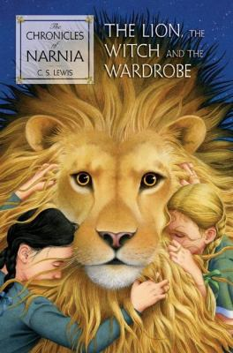 | The Lion, the Witch & the Wardrobe  Narnia…the land beyond the wardrobe, the secret country known only to Peter, Susan, Edmund, and Lucy…the place where the adventure begins.  Lucy is the first to find the secret of the wardrobe in the professor’s mysterious old house. At first, no one believes her when she tells of her adventures in the land of Naria. But soon Edmunc and then Peter and Susan discover the Magin and meet Aslan, the Great Lion, for themselves. In the blink of an eye, their lives are changed forever.
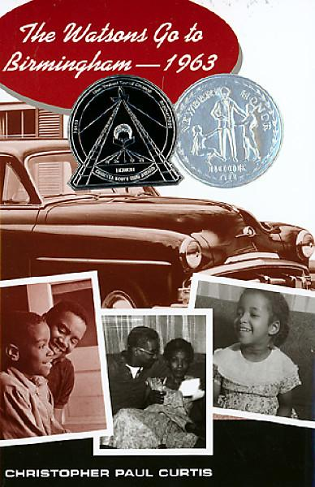 | The Watsons Go to Birmingham, 1963  The year is 1963, and self-important Byron Watson is the bane of his younger brother Kenny's existence. Constantly in trouble for one thing or another, from straightening his hair into a "conk" to lighting fires to freezing his lips to the mirror of the new family car, Byron finally pushes his family too far. Before this "official juvenile delinquent" can cut school or steal change one more time, Momma and Dad finally make good on their threat to send him to the deep south to spend the summer with his tiny, strict grandmother-the one person who can straighten him out. Soon the whole family is packed up, ready to make the drive from Flint, Michigan, straight into one of the most chilling moments in America's history: the burning of the Sixteenth Avenue Baptist Church with four little girls inside.

